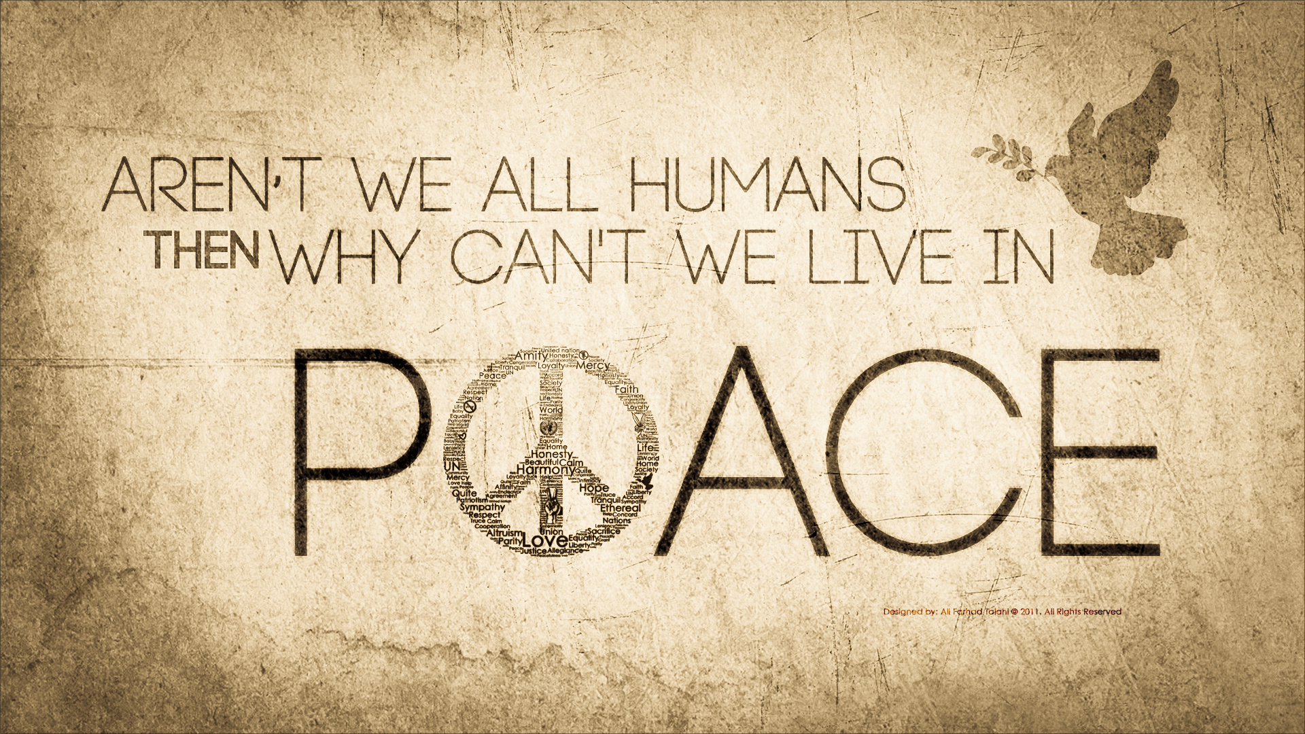

Sam is a 55 year old man from Uganda. He used to be a successful businessman in Uganda and also worked on the railways where he won a customer service award. He is a kind and generous hearted man who does all he can to help others through his volunteering in the UK.

Since 2010 he has been destitute: without the right to work, benefits, education or secondary healthcare. He is denied access to the hospital treatment he desperately needs as he is in constant pain. Sam has severe pain due to medical conditions and needs treatment to reduce his pain and to deal with his underlying health issues. However, he is denied it as he is a refused asylum seeker.

Sam says:

“I feel useless half the time. It's almost like life is not worth living. I was a successful man in my country. Here I rely on handouts from friends, my church, charities and other well-wishers. I don't know what life holds for me, everything is very uncertain. It is so very difficult to live like this”.

“It's not possible for me to return to Uganda. I would not survive there. I have to stay here even though it is miserable because I CANNOT survive in Uganda”.

Sam has depression and anxiety that he developed in the UK. In July he received a letter asking for payment from the NHS for £1000+ for treatment received for his medical conditions. He became so anxious about this letter that he lost consciousness at the top of the stairs and sustaining severe injuries and needing to befelshed into A&E. because he had received a letter asking for paymo anxious about this letter that he lost consciousness at the top of t.

We need to raise awareness and change public perception from the negative media stereotypes to positive images of sanctuary seekers.

Sam says: “We have been deprived of the opportunity to contribute positively to society, we have had our self-esteem ripped from us and we need help but we are denied it. We are human beings too”.

