

Leicester City of Sanctuary
Annual Report September 2011-May 2012

This report covers the nine months since the last AGM. We decided to bring the date of the AGM forward this year so that it coincides more nearly with the end of the financial year, making this and the Treasurer’s report (which covers the 2011-12 financial year) more in line with each other.

Introduction
It is important to remember that we are a very young organisation – National City of Sanctuary is just seven years old, we have been in existence for five. Inevitably both organisations have grown and evolved, and though our ethos and raison d’être are unchanged, some of our priorities have shifted. National City of Sanctuary has now separated from Sheffield and has undertaken a major review of its role, policy and aims for the future. Mick Walker, one of our trustees, is now also a trustee of the national organisation and keeps us abreast of developments. Locally, we have taken the decision to do much more project work with asylum seekers – something that is possible because of the increasing numbers of people who want to volunteer with us. We now have almost 100 volunteers on our database – so many that we have temporarily stopped recruiting. No doubt this will change over the summer – many of our volunteers are students who will finish their courses and go home, others are looking for work and, hopefully, will find employment. However, the amount of man- and woman-power we now have at our disposal does enable us to do a good deal more than we used to. Thanks are due to Julie Burnage, our volunteer co-ordinator, who does sterling work recruiting and supporting our volunteers.

Administrative matters

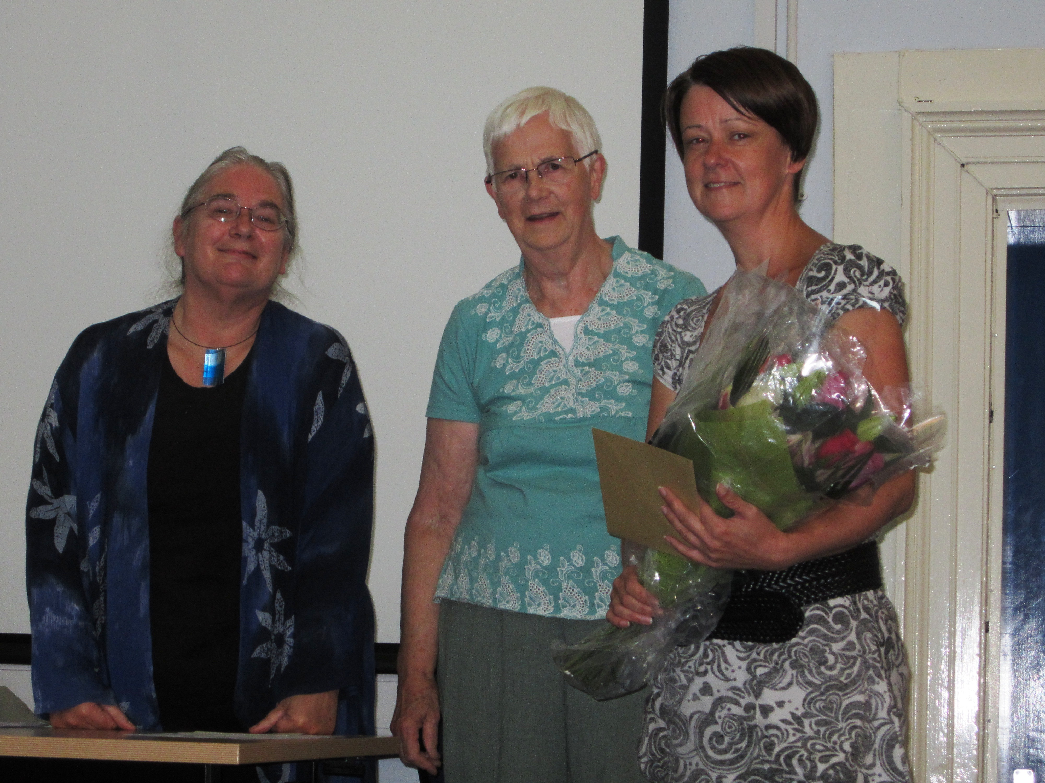
Presentation to Gill buttery, AGM 2011

The key development in this period, signalled at the last meeting, was the loss of our paid member of staff, Gill Buttery. Much of the administrative side of her work is now being done by volunteers. The Zinthiya Trust, a charity which works mainly with disadvantaged women and is based in St Martin’s House, now takes our phone calls, forwards our post and provides on-site office services for the drop-in centre. We pay them a small monthly fee for this service – like us, they are a charity in need of funds.
Gaining charitable status has also brought us its share of administrative headaches and adjustments. As a result, we have worked hard this year to make the administrative side of LCofS more efficient, to divide the work load and get efficient systems in place, making sure we comply with all the Charity Commission’s rules and regulations. Efficiency is of increasing importance as we grow and provide more services.

The drop-in centre
The drop-in centre is thriving. We now get between 20 and 30 clients at each session and since we opened in May 2011 we have seen well over 200 individuals. There are over 400 asylum seekers in Leicester and countless ‘failed’ asylum seekers so we still need to work on publicising the venue – but we’ve made a good start. Red Cross and other agencies now refer vulnerable individuals to us. The range of activities we offer is increasing. We provide internet access and help beginners learn to use computers.

We have a knitting group and a quilting group (donations of odds and ends of wool and fabric would be much appreciated) and we have sewing machines that people can use. Volunteers provide regular therapeutic sessions and LUSH does regular ‘pampering’ afternoons. We are also putting together a programme of activities – bingo, quizzes, live music, poetry, craft workshops and the like – all provided by supporters. Numbers in the English class have grown – for weeks we had one, two, three students or none at all – now we need two teachers. One of the unexpected, but very satisfying spin-offs of setting up the centre is that it provides a forum for supporters to meet asylum seekers. We had a visit from the Deputy Mayor in December, the Soroptimists catered for a Christmas party to which over 50 of our clients came, the young people from the Prince’s Trust organised a ‘Fun Day’ in February, several of our funders have visited, as did a delegation from the Swedish Red Cross and numerous individuals offering gifts and help. Unfortunately the centre was not on the itinerary when the Queen visited St Martin’s House in March, but a number of asylum seekers and volunteers were able to see her and one had a brief conversation with the Duke of Edinburgh.

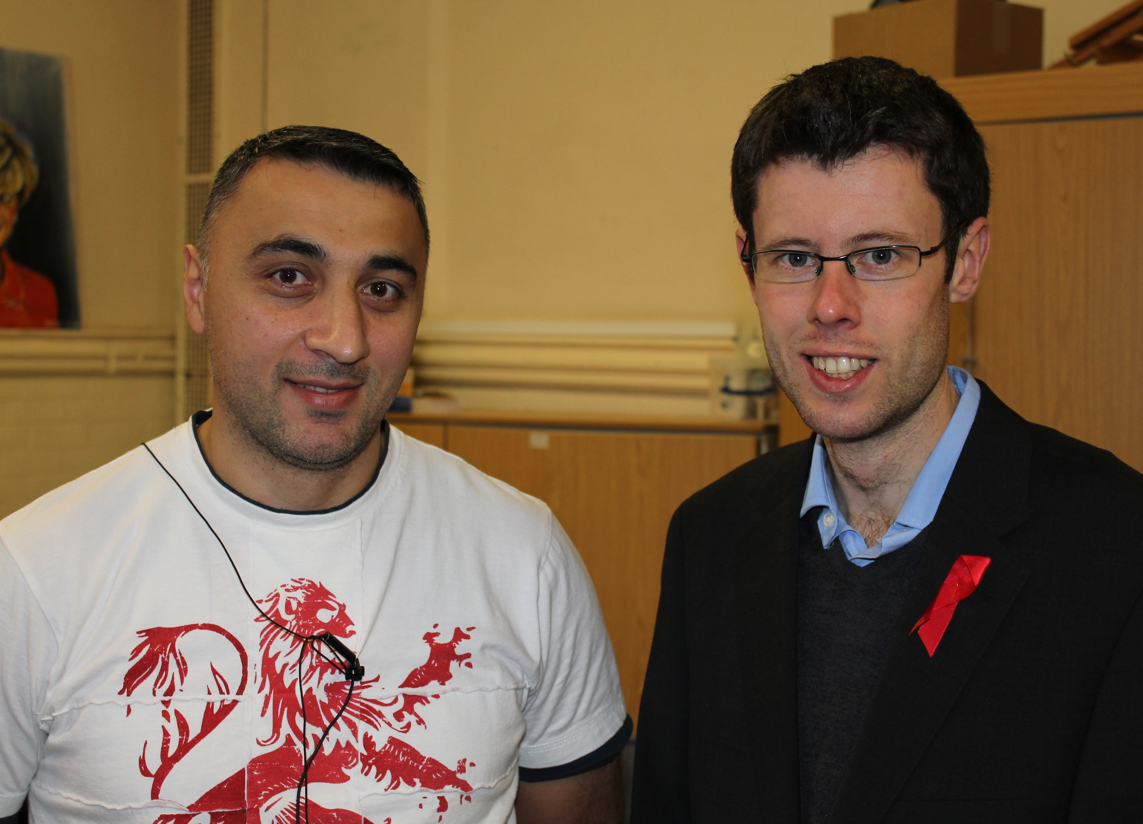
Deputy Mayor, Rory Palmer with refugee artist, Ali
Agayev at the drop-in centre

Inspired by their work at the drop-in centre, a group of students at Leicester University ran their own ‘Refugee Awareness Week’ in March (on the grounds that they would not be in Leicester for the official Refugee Week in June). They organised a most successful series of lectures and events and produced a very interesting, beautifully illustrated booklet featuring stories from a number of our clients.

NEST
The NEST (New Evidence Support Team) is also proving very successful. It sets out to help asylum seekers gather appropriate evidence to support their claims. Clients are referred to us from the Red Cross, Refugee Action and Assist. The Red Cross supports the scheme and gives us invaluable advice. Some of the original volunteers found the work too much and dropped out - it can sometimes be harrowing. For example, one young woman was presented with a video of a client’s brother being decapitated which he wanted to use as evidence for the fact that his family were less than popular in their home country. Greatly to her credit, she is not one of the volunteers who left – and she succeeded in getting the client, who was destitute, back on to NASS support. (We know him well – and the change in his bearing and manner since this intervention has been dramatic). We now have 24 case workers – many of them final year students from the law department at DMU. This is wonderful – but we do have some concerns about how the service will function during exam time and the vacations. All seem to be finding it a positive – if sometimes frustrating – experience, however. Since the scheme started in September 2011 we have had (at the time of writing) 26 referrals. Ten cases are now closed – with varying degrees of success. We realise that the cases coming to us tend to be ‘hard’ ones, where the client has already made inconsistent claims or is uncooperative. All cases, however, increase our insight into the problems faced by asylum seekers generally and inform our ability to give talks and discuss issues – though obviously the details of each individual case are kept confidential. The scheme is attracting a good deal of notice – two of the organisers will run a workshop about it at Leicester University’s ‘Hope and Resilience’ conference on June 19th, other Cities of Sanctuary are expressing interest and Jo Bailey from Nottingham Red Cross has visited us to see how the scheme works.

Hosting
The hosting scheme started to accept referrals in November, and we had two successful hostings over Christmas, both through Refugee Action. Two further referrals did not result in established placements. We have had eleven expressions of interest from potential hosts, but several of these would prefer a female guest, and we have had six referrals for men. There is a steering group, which includes the three referral agencies- Action Homeless, Refugee Action and Red Cross, and representatives for hosts, and for asylum seekers, together with three placement supporters and a coordinator.
We were represented at the Homelessness Summit organised by the City Mayor, but in a time of reducing budgets for public services there were not many solutions on offer for people without access to public funds.
Current issues are: why we are not getting many referrals and the need to provide training for hosts. Funding is currently available thanks to a grant from Compass Children’s Services (we provide weekly expenses of £25 for guests, if needed, for food and transport). To supplement this we have developed a comprehensive list of where free food is available each day in Leicester, both cooked meals and ingredients for meals, kitchen equipment etc. We are looking for alternative sources of funding and are also considering alternative models of hosting.

Appealing4
Appealing4 and Bikes4All continue to respond to requests from asylum seekers. Clients have asked for all sorts of items - from bicycle wheels and kitchen equipment to (rather optimistically, I fear) a webcam.

Outings
We have organised three trips, funded by a grant from the Red Nose fund, one to the Robin Hood Festival, one to Skegness in September that went extremely well (though the temporary loss of one eleven year old at going home time caused a certain amount of panic!) and one to Twinlakes theme park near Melton.

Awareness- and fund-raising
We continue to try to explain to members of the host community what it is really like to be an asylum seeker and have given talks to various groups, including a seminar at County Hall as part of their Holocaust Day activities and a very successful morning at Loughborough Girls’ Grammar School as part of their own charitable event from which they made us a donation.
This year for the first time we had a Leicester City of Sanctuary Christmas card which was designed for free by a volunteer who had just finished a graphic design degree. Sales covered costs and made a tiny profit – and we have a stock of cards left over for next year. It was also useful publicity – we sent cards to various organisations and also gave them to asylum seekers who came to the party, some of whom had never had a Christmas card before.
Fund raising continues to be important, despite our relatively healthy current bank balance. Most of our grants are for one year only, and as the current economic crisis deepens it will be less and less easy to attract grants from other bodies and we will need to become increasingly self-sufficient. To this end, the Friends’ scheme is beginning to produce an appreciable sum each month. We tried to equal the success of our 2011 Summer Fair by holding an Autumn Fair at St Martin’s House in September. It was a joint event with other charities - and we made just £100! Bad weather and an out-of-the-way venue seem to have been to blame. Our cake stall on Leicester Market in March made double the amount for considerably less work. By contrast, our May Fair, earlier this month, was extremely successful, and made just under £1,300 – even better than the 2011 event. Our grateful thanks are due to the organisers, Sue Skyrme and Santok Odedra from Refugee Action


LCofS Christmas card
Publicity
Our fund-raising events provide much-needed publicity for the charity. Various of our volunteers have been interviewed on Radio Leicester – which also organised a link-up through which one of our refugee committee members could speak to his family back home. We have had one ‘First Person’ article in the Leicester Mercury, and a number of letters. Alison Skinner writes an occasional newsletter for our supporters, describing recent LCofS activities and giving information about refugee and asylum issues. However, we are still not as well-known in the city as I would like and this is something that needs to be addressed in the coming year.

In conclusion
Overall, it has been a successful year. Some projects – like FANs – failed to get off the ground. Shopping buddies continues only in a very limited form – the number of section 4 asylum seekers with Azure cards seems to be declining – but our new projects more than make up for them. We hope that 2012-13 will be equally positive.
I would also like to take this opportunity to thank various people – our landlords, Pete Hobson at St Martin’s House and Keith Grayson at Refugee Action; my fellow officers, Bessie Hayes, David Oldershaw and Mick Walker without whose generous help and advice my job would be impossible; Tiffy Allen at NCofS for her constant support; all the other trustees, members of the steering group and our wonderful volunteers (too many to mention by name but we value you all); the asylum seekers and refugees who make doing this work such a pleasure and privilege; and of course you, our friends and supporters. Together we can make a difference.


Chair, Leicester City of Sanctuary

